Pricing Model V5 Executive Summary
Greg Smith · 12 October 2026 · Companion to Contract pricing model: technical design v5

Purpose
The pricing model decides two things for every procedure AA bill: how much it costs, and who receives the invoice.
Every procedure is priced from the published RVG unless a contract with a hospital, insurer, surgeon or anaesthetist sets different terms. This summary covers the business rules and the process for directors, anaesthetists and the office. The data model and calculation detail are in Contract pricing model: technical design v5.

How a procedure is priced
A fee is the procedure's units multiplied by a rate, less any discount, unless a fixed price applies.
Price = (Base + Time + Modifiers) × Rate × (1 − Discount %)
Input | Where it comes from
Base units | The RVG entry for the procedure's anatomical group, chosen by the office or the anaesthetist
Time units | Entered by the anaesthetist after the procedure
Modifier units | Claimed by the anaesthetist, with a note explaining them; zero by default
Rate | The anaesthetist's own unit value, unless a contract sets a rate
Discount | Optional percentage, shown as a separate line on the invoice

A fixed price, rate or discount set by a contract or entered by the anaesthetist, overrides the default RVG calculation. Contracts only state what differs from an RVG style calculation.

Who pays
A Contract is a structured way of thinking about how we solve this question. Under the covers everything is represented as a contract, even “no contract” is a Contract. The selected contract configuration decides who receives the invoice.

Selected contract | Invoice goes to
Default contract (RVG) | The patient, or a guardian or other payer named on the booking
A contract where the contract holder pays | The contract holder is typically an insurer, or a hospital acting an agent for one
A contract where the patient pays (a surgeon's fixed fee, an anaesthetist's price list) | The patient, or the named payer (e.g. guardian)

"No contract" is itself a standing contract held by AA, so every procedure follows the same pricing and billing path. Insured patients who claim the money back themselves are billed as no contract.
If a booking indicates insurance but a patient-billed contract is chosen, the office sees a warning at review. It is not a block, because pre-approval can fall through on the day.

Typical arrangements
Contracts are configurable arrangements. Five arrangements cover most work; a Contract is configured and then can be associated with any procedure.
Here are some typical examples:
Arrangement | Who pays | Price based on | Anaesthetist can change price | Prepaid
No contract (RVG) | Patient | RVG units × anaesthetist's rate | Yes | No
Hospital contract using RVG | Hospital | RVG units | Yes | No
Hospital fixed-price contract | Hospital | Contract price or rate | No | No
Anaesthetist’s prepay price list | Patient | Anaesthetist's own price | Yes | Yes
Surgeon's fixed-fee arrangement | Patient | Surgeon's fixed fee | No | No

Other combinations can be set up for specific billing needs.
The office admin can override any price at any time, and that is the only way to change a fixed price without changing the contract.
In this context, “price” may be any of Price, Rate or Discount %ge.

The process
The office sets up each procedure, the anaesthetist completes it, the office reviews it, and the system prices and invoices it.
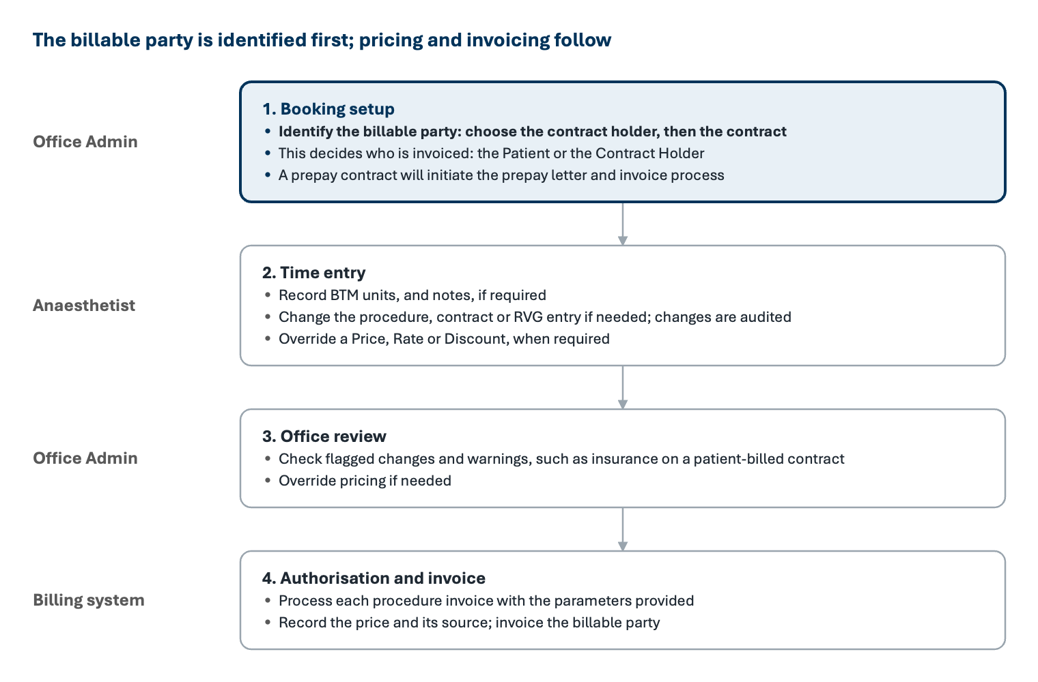
Figure 1. Pricing process, from booking to invoice
The booking list is a starting point: the anaesthetist can change the details, and the office see the changes at review.

Booking Updates
Bookings can undergo numerous changes between the first entry and the procedure day. The system will receive booking updates as PDFs from the surgeon’s rooms as List updates, whenever changes have been made to a List.
Each day, the hospital will provide an updated theatre list of the following days bookings, as a PDF and as a direct data integration.
Changes might include any data field held in the booking.
The system will provide a review and merge capability for office staff to review changes as they are received.

Which price wins
Once a procedure is authorised by an anaesthetist, the pricing is calculated in the order of the following steps. Each step, where the condition is valid, overrides the previous step.:
- RVG calculation: units × rate, less any discount.
- Contract price: the fixed price/rate on the selected contract line.
- Anaesthetist's entry at time entry: a price, rate or discount. Only allowed on contracts the anaesthetist can change.
- Admin override at post time-entry review.
The system records which rule (above) set the price, so nominated prices and overrides are easy to report on. A price of zero produces a no-charge invoice, with the units still recorded.
Prices are calculated using the contract version in force on the procedure date.

Prepayment
Prepaid procedures, common for cosmetic surgery, are collected up front at an estimated price and settled after the procedure.
- At booking, the office selects the anaesthetist's prepay contract. This starts the automated prepay process (letter and invoice).
- The amount is always the fixed price on that contract's line.
- After the procedure, the anaesthetist confirms or changes the price:
  - Unchanged: nothing more is billed.
  - Raised: the difference is invoiced.
  - Lowered, by price or discount: the difference is refunded.

Price reviews and controls
This area is still under active design discussion, but here is the status:
A contract holder’s revised price schedule (e.g. Christchurch Eye) is loaded as a new version; the old version closes the day before the start date, and nothing is deleted.
- Price reviews. The holder's full schedule is loaded as a new contract version with its start date. Lines are matched to the previous version by their reference code, and a preview shows new, changed and removed lines before anything is applied. Removed lines still used by live bookings are highlighted.
- Non-editable prices. Each contract states whether anaesthetists may change its prices. Hospital fixed-price contracts are normally non-editable; RVG-based contracts are not.
- Audit. Changes to a booking's contract or procedure at time entry need no reason, but are recorded and flagged at office review. Changes to RVG groups, contract holders and contracts are audited.
- Routine procedures. Frequently performed procedures can be loaded as lines on the no-contract arrangement, so the office or anaesthetist can pick them quickly. Their descriptions appear on the invoice.
- No common pricing. AA does not set prices for its members. The no-contract arrangement carries no practice-wide prices, which competition law does not allow.
- Data loading. AA prepares all reference data in spreadsheet templates. The first release uses a developer-run import, with office screens to create, edit and retire records.

